**MeetSpace**

*A community for the students by the students*

Table of Contents

|  |  |  |
| --- | --- | --- |
| SL No. | Chapter Name | PAGE NUMBER |
|  | List of Figures | 4 |
| 1. | Introduction | 5 |
| 1.1 | Abstract | 5 |
| 1.2 | Background | 5 |
| 1.3 | Problem statement | 5 |
| 1.4 | Project Scope | 5 |
| 2. | Overview and Planning | 6 |
| 2.1 | Project Requirements | 6 |
| 2.2 | Flowchart of operations | 7 |
| 2.3 | ER Diagram | 8 |
| 2.4 | Relationships and Cardinality | 8 |
| 3. | ALGORITHM | 10 |
| 4. | Output Screenshots | 12 - 17 |
| 5. | Conclusion | 17 |
| 6. | References | 18 |

**MeetSpace**

*A community for the students by the students*

List of Figures

|  |  |
| --- | --- |
| Figure Number | Page Number |
| Figure 1 | 7 |
| Figure 2 | 8 |
| Figure 3 | 8 |
| Figure 4 | 12 |
| Figure 5 | 12 |
| Figure 6 | 13 |
| Figure 7 | 13 |
| Figure 8 | 14 |
| Figure 9 | 14 |
| Figure 10 | 15 |
| Figure 11 | 15 |
| Figure 12 | 16 |
| Figure 13 | 16 |
| Figure 14 | 17 |

1. **Introduction:**

MeetSpace is a platform where students can find themselves a fellow student tutor to guide and assist them with their selected subjects on their preferred days and time. This platform is greatly beneficial to students with a smaller network to get in touch with other students that can tutor a requested subject. This creates a personalized non-classroom setting that provides a more comfortable learning experience. This platform will help tutors gain valuable teaching experience and will facilitate better networking amongst students to provide support in their academics and other aspects of student life. This platform is not intended to replace professors but to co-exist with them.

* 1. **Abstract:**

The project “MeetSpace” works as follows: A student-instructor database will be created to match students and instructors based on common slots and subject preferences.

* 1. **Background:**

This project carries an educational background and is primarily aimed to be launched in that field of use only. Upon deployment, a strong beneficial student community can be created to provide support and comfort.

* 1. **Problem Statement:**

The objective of this project is to create a beneficial student society where students can find fellow student tutors to mentor them through a subject on their preferred days and time.

* 1. **Project Scope:**

This project provides a system that differs from the conventional system of primarily relying on professors for academic help. The proposed system does not currently exist in the educational field and is aimed to be deployed in college amongst students.

1. **Overview and Planning** 
   1. **Project Requirements**

* Backend development
  + Software used: PHP
* Database creation
  + Software used: MySQL
* Frontend development to create interactive website
  + Software used: HTML, CSS and JavaScript
  1.** 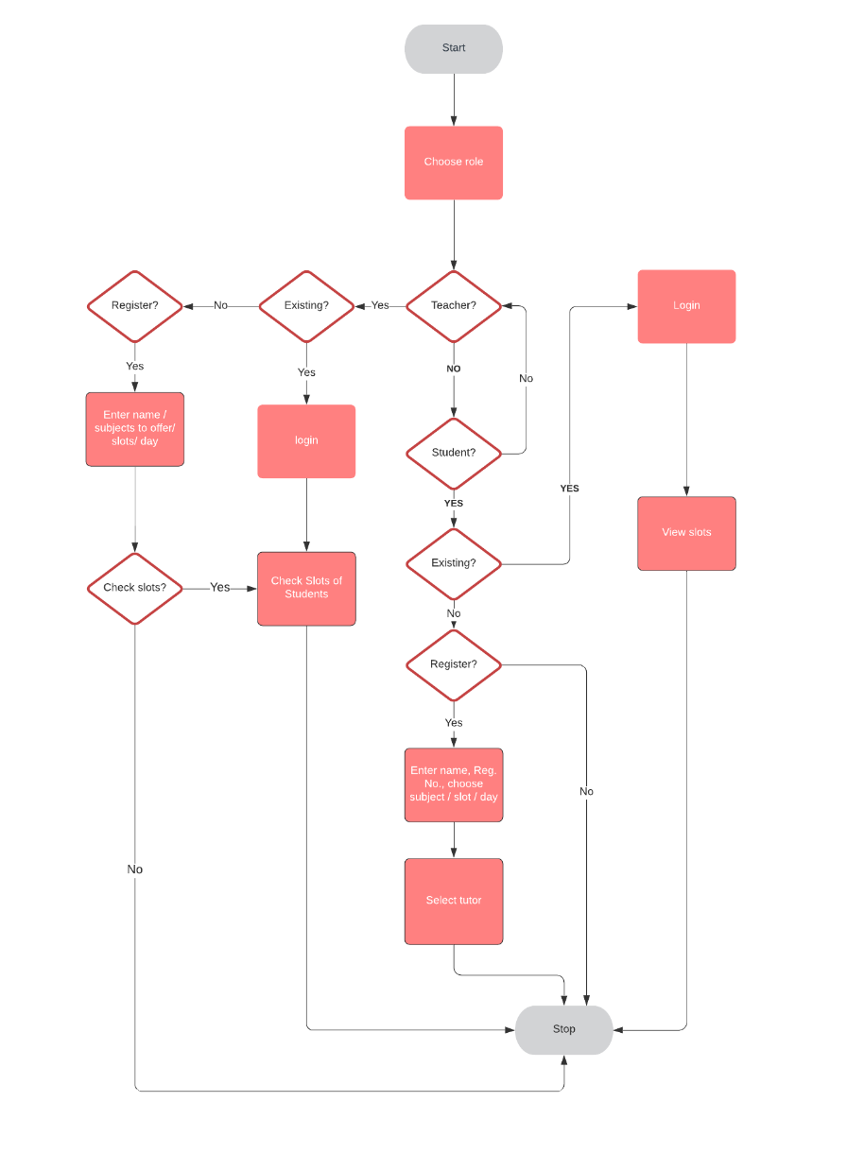. Flowchart of operations**

*FIGURE 1 – Flowchart(Detailed description mentioned in the algorithm)*

* 1.** 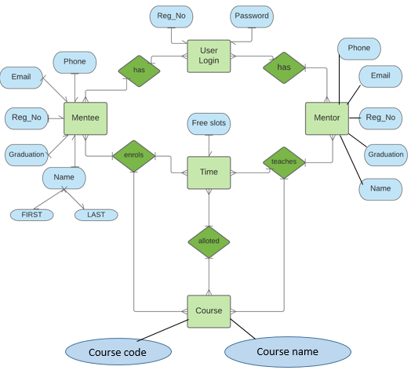. ER diagram**

*FIGURE 2*

*Diagram shows the attributes and relationships of the project*

* 1. **. Relationships and Cardinality**

1.

M

N

SELECT

TIME

MENTEE

2.

M

N

SELECT

TIME

MENTOR

3.

ENROLSLS

M

N

COURSE

MENTEE

4.

TEACHSS

M

N

COURSE

MENTOR

5.

M

N

ALLOT

TIME

COURSE

6.

1

1

HAS

LOGIN

MENTEE

7.

1

1

HAS

LOGIN

MENTOR

*FIGURE 3*

*Diagrams represent the relationship between each attribute and the cardinality*

1. **Algorithm**
2. Create index page that acts as home page for the entire website
3. The index page has HTML skeleton that will link to –
   1. HOME
   2. ABOUT
   3. LOGIN
   4. STUDENT REGISTRATION
   5. INSTRUCTOR REGISTRATION
4. Create CSS file called styles.css to link to html forms
5. In ABOUT page display details of web application
6. Under student registration HTML skeleton-
   1. Link to student registration php form where REGISTRATION NUMBER ,NAME , NUMBER ,EMAIL ,and PASSWORD are taken
   2. Connect this PHP form to the database “MeetSpace” using connection.php
7. Repeat same for instructor registration
8. After registration, link students to student-preferences html form
9. In backend connect student registration to student-preferences php form and take preferred subject and preferred day and slot and update the values into database table student_pref
10. Similarly link instructor registration page to instructor- preferences page and take the required details and update to instructor_pref table
11. Use INNER JOIN SQL query on tables student_pref and instructor_pref to select instructor with common slot timing and day.
12. Student selects the instructors they want in available time slot.
13. Student preferences and available instructors are **matched** by selecting values from student-pref and instructor-pref tables inner join into final table
14. Login page access using reg number and password and linking to two different pages for student and instructor respectively
15. In student login, display their instructor and instructor details from table final and display their own information from student table
16. In instructor login display their students with student information from table final and display their own information from instructor table
17. Logout is linked back to login page
18. TABLE CREATED IN DATABASE:
    1. Student- in student registration form to collect student details
    2. Instructor- in instructor registration form to collect details
    3. Student_pref in student-preferences form to collect subject day and slot
    4. Instructor_pref in instructor-preferences collect the subject day slot
    5. Create table Final in info-store form taking reg no,subject,date,slot,instructor

1. **Output Screenshots**

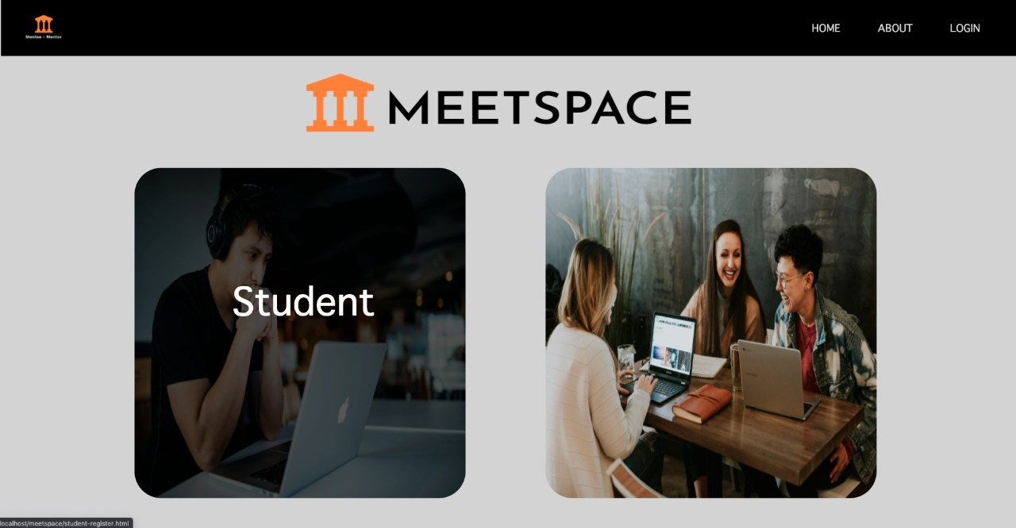

*FIGURE 4 – Home Page*

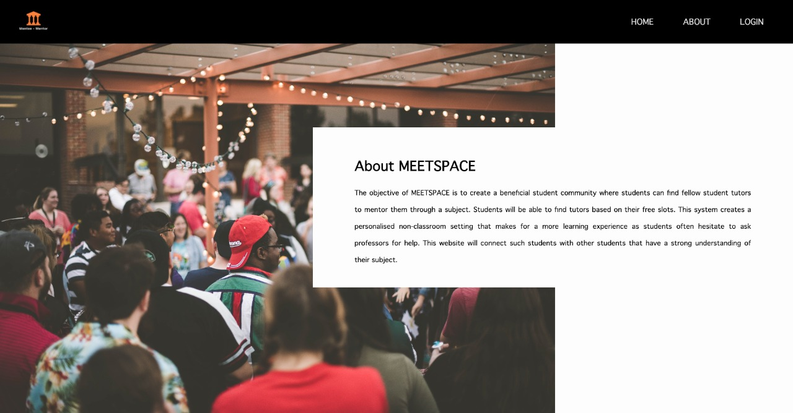*Home Page where you can register/login as a student or instructor*

*FIGURE 5 – About Page*

*Provides a description of our website*

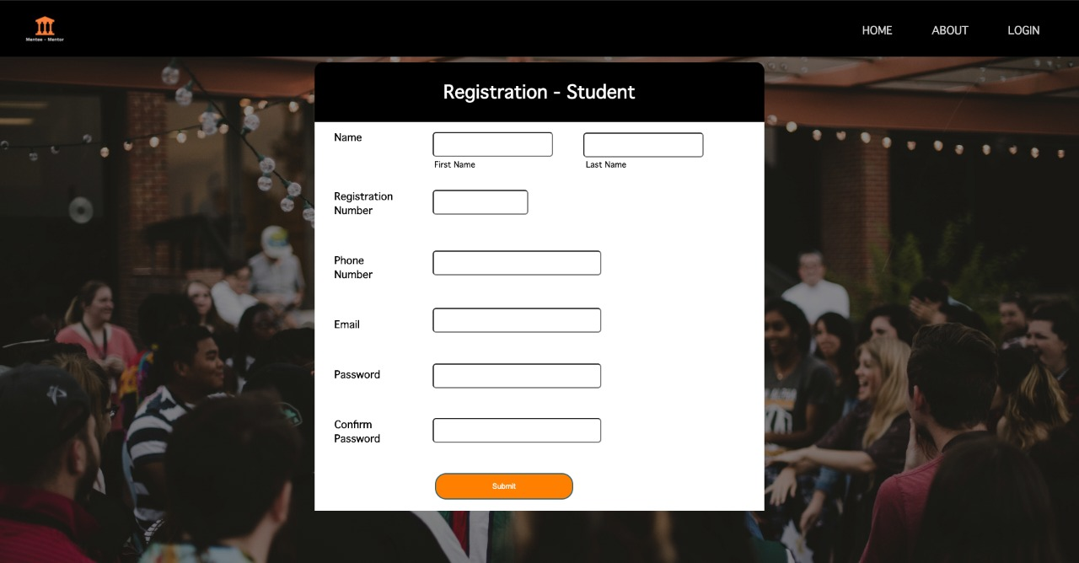*FIGURE 6 – Student Registration Page*

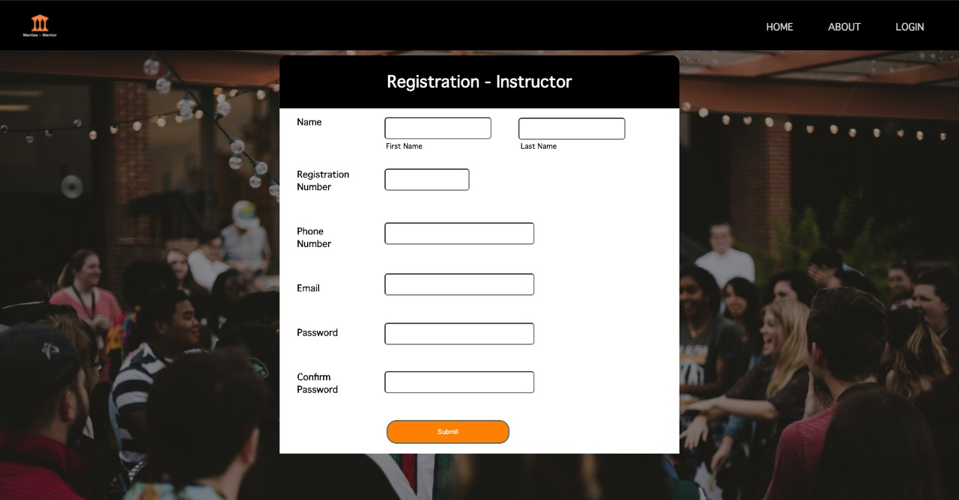*Enter the required fields to register as a student*

FIGURE 7 – Instructor Registration Page

Enter the required fields to register as an instructor

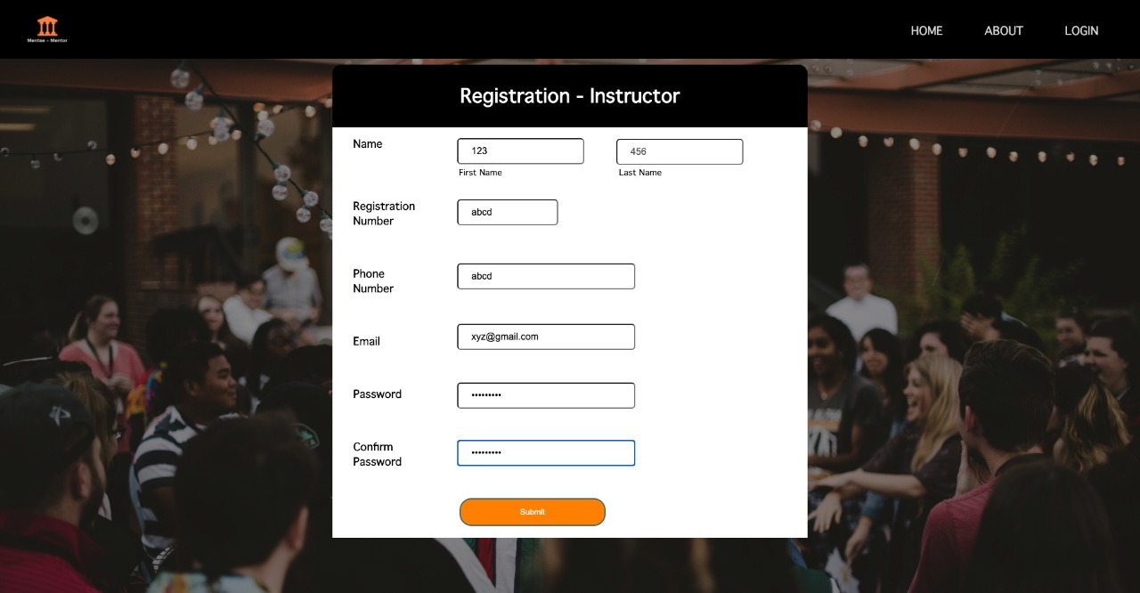*FIGURE 8*

*Checking for validation of fields*

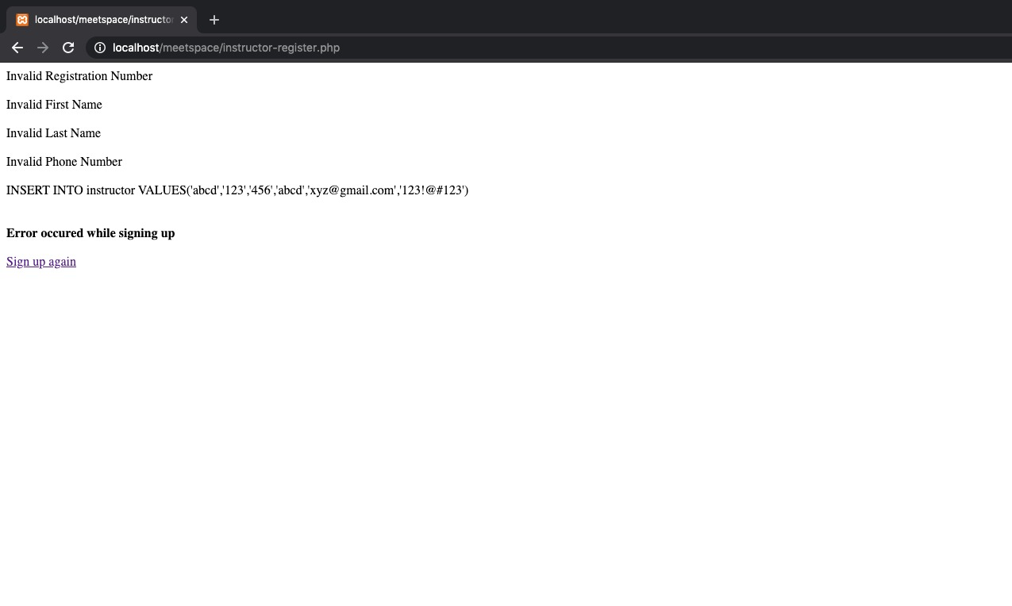

*FIGURE 9*

*Fields have been validated*

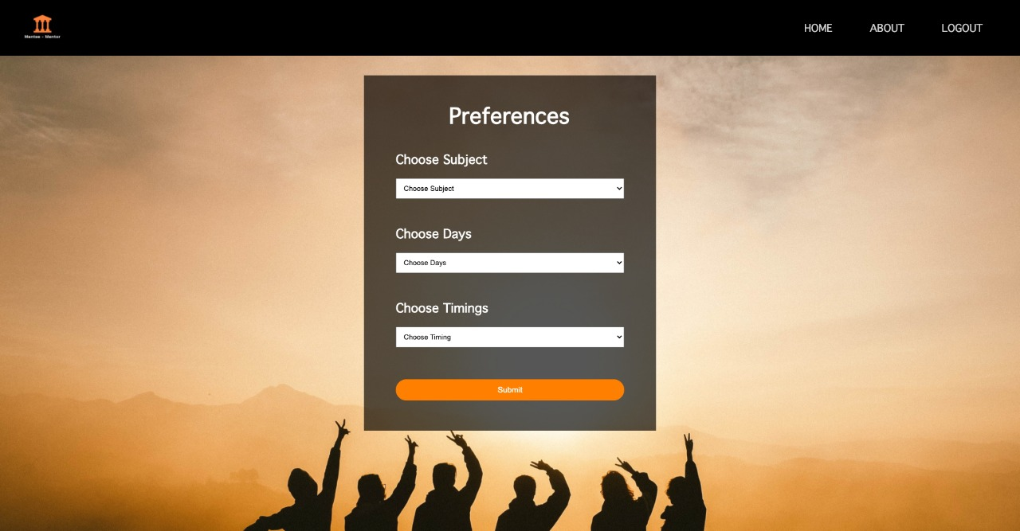*FIGURE 10 - Preferences Page*

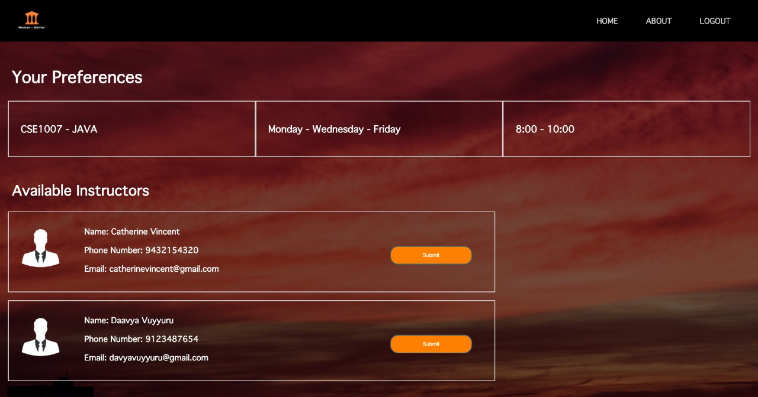*Choose preferred subject, days and timings*

*FIGURE 11 – Instructor Selection Page*

*Select any available instructor*

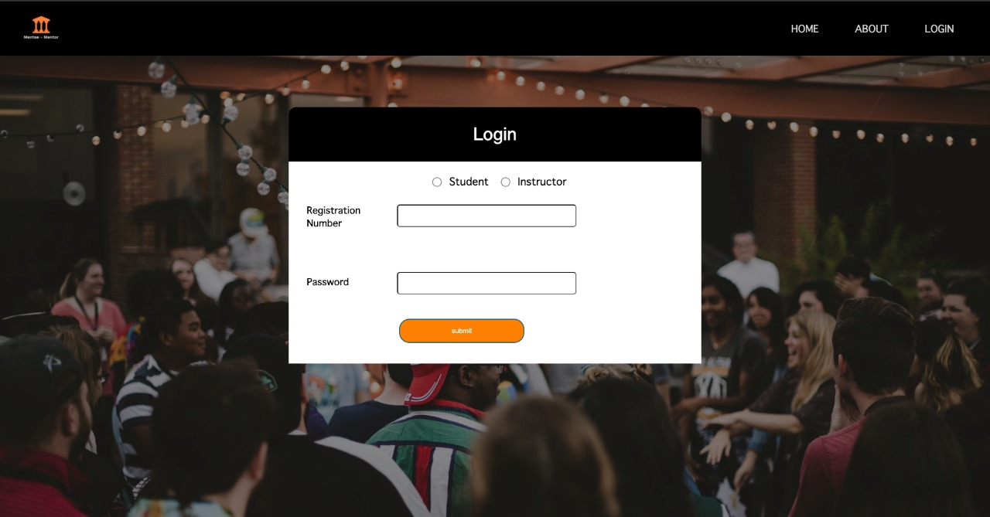*FIGURE 12 – Login Page*

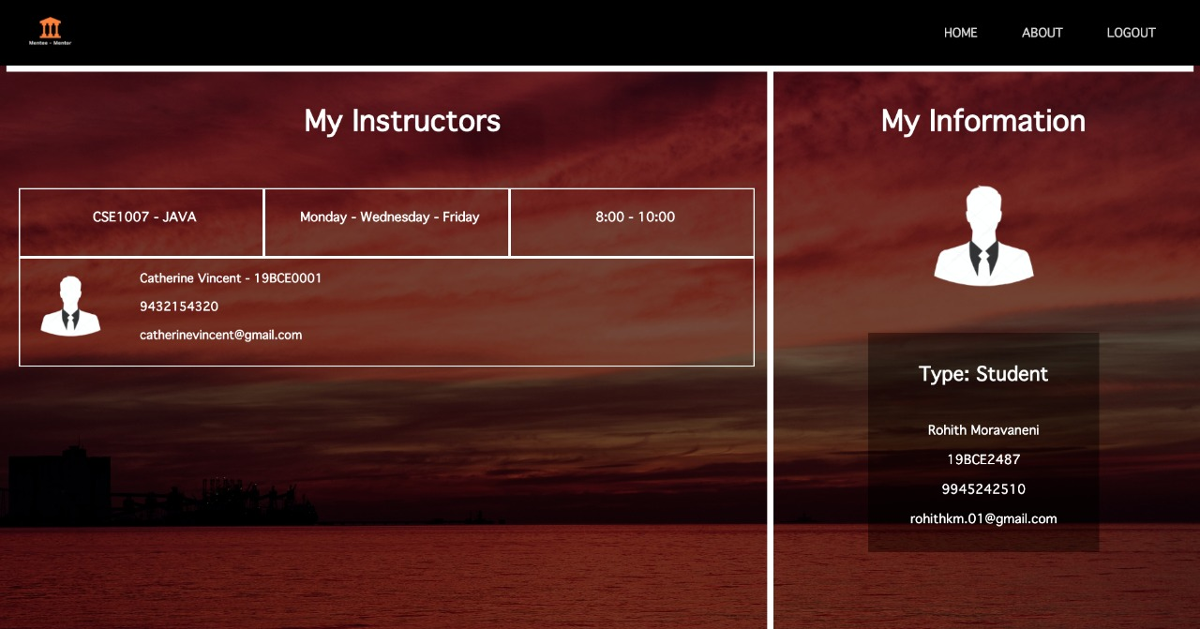*on choosing role, login with registration number and password*

*FIGURE 13 - Student Dashboard*

*Student dashboard that displays one’s details and current instructors*

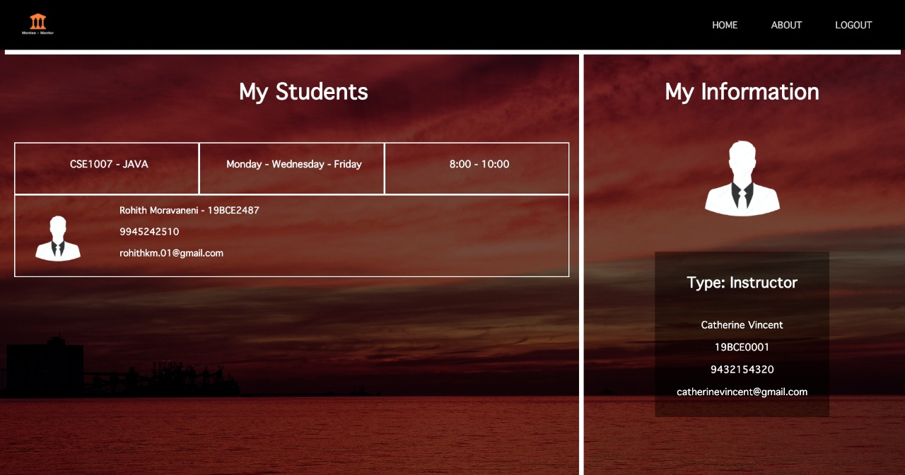*FIGURE 14 - Instructor Dashboard*

*Instructor dashboard that displays one’s details and current students*

1. **Conclusion**

“MeetSpace” creates a strong beneficial student community where students can find themselves a fellow student tutor to guide and assist them. Networking amongst students becomes a lot easier and faster using our project. Students will not only excel in their studies, but will also develop soft skills such as communication, attitude, and work ethic that will allow them to effectively interact with others. Most importantly, “MeetSpace”, will form lasting relationships and create a comfortable environment for students to thrive in.

1. **References**

Agarwal ·, N. (2020, May 20). Create a Login System Using HTML, PHP, and MySQL - DZone Web Dev. Retrieved October 24, 2020, from https://dzone.com/articles/ceate-a-login-system-using-html-php-and-mysql

How TO - Tooltip. (n.d.). Retrieved October 19, 2020, from https://www.w3schools.com/howto/howto_css_tooltip.asp

HTML Tutorial. (n.d.). Retrieved October 17, 2020, from https://www.tutorialspoint.com/html/index.htm

Rascia, T. (2017, May 16). Build a PHP & MySQL CRUD Database App From Scratch. Retrieved October 15, 2020, from <https://www.taniarascia.com/create-a-simple-database-app-connecting-to-mysql-with-php/>

Roy, S., & Bashford, J. (2012, April 01). Display Text on Hover Item with Javascript. Retrieved October 19, 2020, from https://stackoverflow.com/questions/54487585/display-text-on-hover-item-with-javascript

Valade, J. (n.d.). PHP &amp; MySQL For Dummies Cheat Sheet. Retrieved October 18, 2020, from https://www.dummies.com/programming/php/php-mysql-for-dummies-cheat-sheet/